等待队列
(整理：zhoulong<longer.zhou@gmail.com>)
一、wait queue
When a process is waiting on an external event to occur, it is removed from the run queue and placed on a wait queue. Wait queues are doubly linked lists of wait_queue_t structures. The wait_queue_t structure is set up to hold all the information required to keep track of a waiting task. All tasks waiting on a particular external event are placed in a wait queue. The tasks on a given wait queue are woken up, at which point the tasks verify the condition they are waiting for and either resume sleep or remove themselves from the wait queue and set themselves back to TASK_RUNNING.

A wait queue is a doubly linked list of wait_queue_t structures that hold pointers to the process task structures of the processes that are blocking. Each list is headed up by a wait_queue_head_t structure, which marks the head of the list and holds the spinlock to the list to prevent wait_queue_t additional race conditions.Figure 3.14 illustrates wait queue implementation. We now look at the wait_queue_t and the wait_queue_head_t structures:
---------------------------------------------------------------------
include/linux/wait.h
19 typedef struct __wait_queue wait_queue_t;
...
23 struct __wait_queue {
24 unsigned int flags;
25 #define WQ_FLAG_EXCLUSIVE 0x01
26 struct task_struct * task;
27 wait_queue_func_t func;
28 struct list_head task_list;
29 };
30
31 struct __wait_queue_head {
32 spinlock_t lock;
33 struct list_head task_list;
34 };
35 typedef struct __wait_queue_head wait_queue_head_t;
---------------------------------------------------------------------
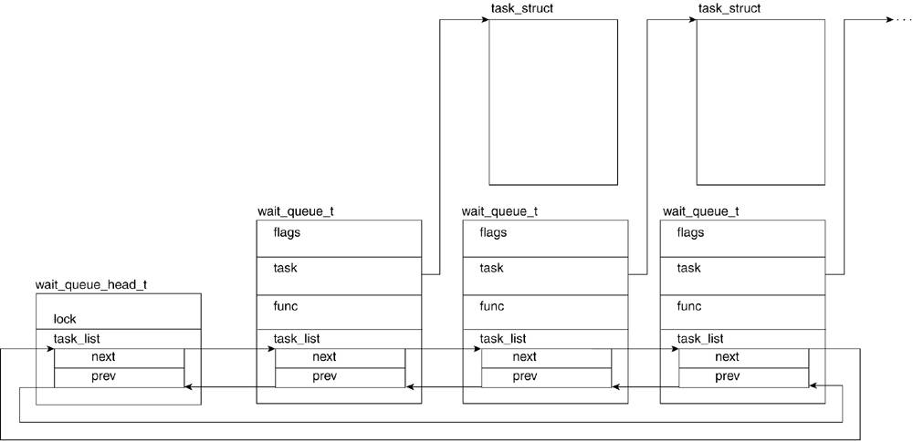

The wait_queue_t structure is comprised of the following fields:
- flags. Can hold the value WQ_FLAG_EXCLUSIVE, which is set to 1, or ~WQ_FLAG_EXCLUSIVE, which would be 0. The WQ_FLAG_EXCLUSIVE flag marks this process as an exclusive process. Exclusive and non-exclusive processes are discussed in the next section.
- task. The pointer to the task descriptor of the process being placed on the wait queue.
- func. A structure holding a function used to wake the task on the wait queue. This field uses as default default_wake_function(), which is covered in detail in the section, "Waiting on the Event."
wait_queue_func_t is defined as follows:
---------------------------------------------------------------
include/linux/wait.h
typedef int (*wait_queue_func_t)(wait_queue_t *wait,
unsigned mode, int sync);
---------------------------------------------------------------

where wait is the pointer to the wait queue, mode is either TASK_ INTERRUPTIBLE or TASK_UNINTERRUPTIBLE, and sync specifies if the wakeup should be synchronous.
- task_list. The structure that holds pointers to the previous and next elements in the wait queue.
The structure __wait_queue_head is the head of a wait queue list and is comprised of the following fields:
- lock. One lock per list allows the addition and removal of items into the wait queue to be synchronized.
- task_list. The structure that points to the first and last elements in the wait queue.
二、加入等待队列步骤
1. 声明wait_queue_head_t 和wait_queue_t
⑴ wait_queue_head_t声明。有两种方法：
  - void init_waitqueue_head(wait_queue_head_t *queue);[at runtime]
  - DECLARE_WAIT_QUEUE_HEAD(queue); (at compile time)
⑵ wait_queue_t声明。有两种方法
① DECLARE_WAITQUEUE(name, tsk) or DEFINE_WAIT(name)
② init_waitqueue_entry (wait_queue_t *q, struct task_struct *p) (或者其他定义在kernel/wait.c or wait.h的函数)

⒉ 把wait_queue_t加入到wait_queue_head_t中。主要通过下面这两个函数:
Two different functions are used to add sleeping processes into a wait queue: add_wait_queue() and add_wait_queue_exclusive(). The two functions exist to accommodate the two types of sleeping processes. Non-exclusive waiting processes are those that wait for the return of a condition that is not shared by other waiting processes. Exclusive waiting processes are waiting for a condition that another waiting process might be waiting on, which potentially generates a race condition.
The add_wait_queue() function inserts a non-exclusive process into the wait queue. A non-exclusive process is one which will, under any circumstance, be woken up by the kernel when the event it is waiting for comes to fruition. The function sets the flags field of the wait queue struct, which represents the sleeping process to 0, sets the wait queue lock to avoid interrupts accessing the same wait queue from generating a race condition, adds the structure to the wait queue list, and restores the lock from the wait queue to make it available to other processes:

---------------------------------------------------------------------
kernel/wait.c
93 void add_wait_queue(wait_queue_head_t *q, wait_queue_t * wait)
94 {
95 unsigned long flags;
96
97 wait->flags &= ~WQ_FLAG_EXCLUSIVE;
98 spin_lock_irqsave(&q->lock, flags);
99 __add_wait_queue(q, wait); /*加入到队列的第一个位置*/
100 spin_unlock_irqrestore(&q->lock, flags);
101 }
---------------------------------------------------------------------

The add_wait_queue_exclusive() function inserts an exclusive process into the wait queue. The function sets the flags field of the wait queue struct to 1 and proceeds in much the same manner as add_wait_queue() exclusive, with the exception that it adds exclusive processes into the queue from the tail end. This means that in a particular wait queue, the non-exclusive processes are at the front and the exclusive processes are at the end. This comes into play with the order in which the processes in a wait queue are woken up, as we see when we discuss waking up sleeping processes:

---------------------------------------------------------------------
kernel/wait.c
105 void add_wait_queue_exclusive(wait_queue_head_t *q, wait_queue_t * wait)
106 {
107 unsigned long flags;
108
109 wait->flags |= WQ_FLAG_EXCLUSIVE;
110 spin_lock_irqsave(&q->lock, flags);
111 __add_wait_queue_tail(q, wait);/*加入到队列的最后一个位置*/
112 spin_unlock_irqrestore(&q->lock, flags);
113 }
---------------------------------------------------------------------
这两个函数的区别

⒊ 设置进程状态为TASK_INTERRUPTIBLE or TASK_UNINTERRUPTIBLE. (通过set_current_state)
⒋ 测试条件，如果条件为假，则调用schedule()进入休眠状态(等待)
⒌ 从schedule()返回，设置进程状态为TASK_RUNNING
(注： 从schedule返回，并不代表外部事件产生，因为有可能因为信号中断，而返回，所以从schedule返回时，一般需要再测试条件)
⒍ 当事件产生时，从等待队列移除，通过下面这个函数

Kernel/wait.c
void remove_wait_queue(wait_queue_head_t *q, wait_queue_t *wait)
{
unsigned long flags;

spin_lock_irqsave(&q->lock, flags);
__remove_wait_queue(q, wait);
spin_unlock_irqrestore(&q->lock, flags);
}
---------------------------------------------------------------------
三、wait_event* 宏
The wait_event*() interfaces include wait_event(), wait_event_ interruptible(), and wait_event_interruptible_timeout().Figure 3.15 shows the function skeleton calling routing. 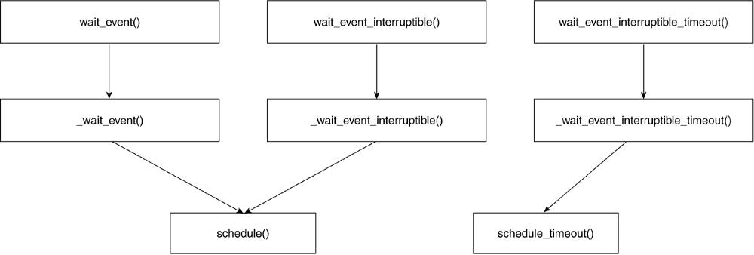
We go through and describe the interfaces related to wait_event() and mention what the differences are with respect to the other two functions. The wait_event()interface is a wrapper around the call to __wait_event() with an infinite loop that is broken only if the condition being waited upon returns.wait_event_interruptible_timeout() passes a third parameter called ret of type int, which is used to pass the timeout time.
wait_event_interruptible() is the only one of the three interfaces that returns a value. This return value is ERESTARTSYS if a signal broke the waiting event, or 0 if the condition was met:
---------------------------------------------------------------------
include/linux/wait.h
137 #define wait_event(wq, condition)
138 do {
139 if (condition)
140 break;
141 __wait_event(wq, condition);
142 } while (0)
---------------------------------------------------------------------

The __wait_event() interface does all the work around the process state change and the descriptor manipulation:
---------------------------------------------------------------------
include/linux/wait.h
121 #define __wait_event(wq, condition)
122 do {
123 wait_queue_t __wait;
124 init_waitqueue_entry(&__wait, current);
125
126 add_wait_queue(&wq, &__wait);
127 for (;;) {
128 set_current_state(TASK_UNINTERRUPTIBLE);
129 if (condition)
130 break;
131 schedule();
132 }
133 current->state = TASK_RUNNING;
134 remove_wait_queue(&wq, &__wait);
135 } while (0)
---------------------------------------------------------------------
四、等待队列的唤醒
A process must be woken up to verify whether its condition has been met. Note that a process might put itself to sleep, but it cannot wake itself up. Numerous macros can be used to wake_up tasks in a wait queue but only three main "wake_up" functions exist. The macros wake_up, wake_up_nr, wake_up_all, wake_up_ interruptible,wake_up_interruptible_nr,and wake_up_interruptible_all all call __wake_up() with different parameters. The macros wake_up_all_sync andwake_up_interruptible_sync both call __wake_ up_sync() with different parameters. Finally, the wake_up_locked macro defaults to the __wake_up_locked() function: ---------------------------------------------------------------------
include/linux/wait.h
116 extern void FASTCALL(__wake_up(wait_queue_head_t *q,
unsigned int mode,
int nr));
117 extern void FASTCALL(__wake_up_locked(wait_queue_head_t *q,
unsigned int mode));
118 extern void FASTCALL(__wake_up_sync(wait_queue_head_t *q,
unsigned int mode,
int nr));

120 #define wake_up(x) __wake_up((x),TASK_UNINTERRUPTIBLE | TASK_INTERRUPTIBLE, 1)
121 #define wake_up_nr(x, nr) __wake_up((x),TASK_UNINTERRUPTIBLE | TASK_INTERRUPTIBLE, nr)
122 #define wake_up_all(x) __wake_up((x),TASK_UNINTERRUPTIBLE | TASK_INTERRUPTIBLE, 0)
123 #define wake_up_all_sync(x) _wake_up_sync((x),TASK_UNINTERRUPTIBLE | TASK_INTERRUPTIBLE, 0)
124 #define wake_up_interruptible(x) __wake_up((x),
TASK_INTERRUPTIBLE, 1)
125 #define wake_up_interruptible_nr(x, nr) __wake_up((x),TASK_INTERRUPTIBLE, nr)
126 #define wake_up_interruptible_all(x) __wake_up((x),TASK_INTERRUPTIBLE, 0)
127 #define wake_up_locked(x) __wake_up_locked((x), TASK_UNINTERRUPTIBLE | TASK_INTERRUPTIBLE)
128 #define wake_up_interruptible_sync(x) __wake_up_sync((x),TASK_INTERRUPTIBLE, 1 )
---------------------------------------------------------------------
Let's look at __wake_up():
---------------------------------------------------------------------
kernel/sched.c
2336 void fastcall __wake_up(wait_queue_head_t *q, unsigned int mode, int nr_exclusive)
2337 {
2338 unsigned long flags;
2339
2340 spin_lock_irqsave(&q->lock, flags);
2341 __wake_up_common(q, mode, nr_exclusive, 0);
2342 spin_unlock_irqrestore(&q->lock, flags);
2343 }
---------------------------------------------------------------------

Line 2336
The parameters passed to __wake_up include q, the pointer to the wait queue; mode, the indicator of the type of thread to wake up (this is identified by the state of the thread); and nr_exclusive, which indicates whether it's an exclusive or non-exclusive wakeup. An exclusive wakeup (when nr_exclusive = 0) wakes up all the tasks in the wait queue (both exclusive and non-exclusive), whereas a non-exclusive wakeup wakes up all the non-exclusive tasks and only one exclusive task.

Lines 2340, 2342
These lines set and unset the wait queue's spinlock. Set the lock before calling __wake_up_common()to ensure no race condition comes up.

Line 2341
The function __wake_up_common() performs the bulk of the wakeup function:
---------------------------------------------------------------------
kernel/sched.c
2313 static void __wake_up_common(wait_queue_head_t *q,
unsigned int mode, int nr_exclusive, int sync)
2314 {
2315 struct list_head *tmp, *next;
2316
2317 list_for_each_safe(tmp, next, &q->task_list) {
2318 wait_queue_t *curr;
2319 unsigned flags;
2320 curr = list_entry(tmp, wait_queue_t, task_list);
2321 flags = curr->flags;
2322 if (curr->func(curr, mode, sync) &&
2323 (flags & WQ_FLAG_EXCLUSIVE) &&
2324 !--nr_exclusive)
2325 break;
2326 }
2327 }
---------------------------------------------------------------------

Line 2313
The parameters passed to __wake_up_common are q, the pointer to the wait queue; mode, the type of thread to wake up; nr_exclusive, the type of wakeup previously shown; and sync, which states whether the wakeup should be synchronous.

Line 2315
Here, we set temporary pointers for list-entry manipulation.

Line 2317
The list_for_each_safe macro scans each item of the wait queue. This is the beginning of our loop.

Line 2320
The list_entry macro returns the address of the wait queue structure held by the tmp variable.

Line 2322
The wait_queue_t's func field is called. By default, this calls default_wake_function(), which is shown here:
---------------------------------------------------------------------
kernel/sched.c
2296 int default_wake_function(wait_queue_t *curr, unsigned mode,
int sync)
2297 {
2298 task_t *p = curr->task;
2299 return try_to_wake_up(p, mode, sync);
2300 }
---------------------------------------------------------------------

This function calls try_to_wake_up() (kernel/sched.c) on the task pointed to by the wait_queue_t structure. This function performs the bulk of the work of waking up a process, including putting it on the run queue.

Lines 2322 2325
The loop terminates if the process being woken up is the first exclusive process. This makes sense if we realize that all the exclusive processes are queued at the end of the wait queue. After we encounter the first exclusive task in the wait queue all remaining tasks will also be exclusive so we do not want to wake them and we break out of the loop.
wake_up系列宏怎么用？
主要是看加入等待队列时，设置的任务状态，如果设置了TASK_INTERRUPTIBLE,则唤醒时用wake_up_interruptible*系列宏。而wake_up*系列宏则会把设置了TASK_INTERRUPTIBLE 和TASK_UNINTERRUPTIBLE的任务唤醒。
wake_up,
wake_up_nr,
wake_up_all,
wake_up_interruptible,
wake_up_interruptible_nr,
wake_up_interruptible_all,
wake_up_interruptible_sync,
wake_up_locked

所有宏都考虑到了处于TASK_INTERRUPTIBLE状态的睡眠进程；如果宏的名字中不含字符串"interruptible",则还将考虑处于 TASK_UNINTERRUPTIBLE状态的睡眠进程；
名字中含有“nr”字符串的宏唤醒给定数字的具有所需状态的互斥进程；
名字中含有"all"字符串的宏唤醒具有所需状态的所有互斥进程。
最后，名字中不 含"nr"或"all"字符串的宏只唤醒具有所需状态一个互斥进程

五、有关等待队列的其他常见操作函数
void prepare_to_wait(wait_queue_head_t *q, wait_queue_t *wait, int state)
{
unsigned long flags;

wait->flags &= ~WQ_FLAG_EXCLUSIVE;
spin_lock_irqsave(&q->lock, flags);
if (list_empty(&wait->task_list))
__add_wait_queue(q, wait);
set_current_state(state);
spin_unlock_irqrestore(&q->lock, flags);
}

Void prepare_to_wait_exclusive(wait_queue_head_t *q, wait_queue_t *wait, int state)
{
unsigned long flags;

wait->flags |= WQ_FLAG_EXCLUSIVE;
spin_lock_irqsave(&q->lock, flags);
if (list_empty(&wait->task_list))
__add_wait_queue_tail(q, wait);
set_current_state(state);
spin_unlock_irqrestore(&q->lock, flags);
}

void finish_wait(wait_queue_head_t *q, wait_queue_t *wait)
{
unsigned long flags;

__set_current_state(TASK_RUNNING);
if (!list_empty_careful(&wait->task_list)) {
spin_lock_irqsave(&q->lock, flags);
list_del_init(&wait->task_list);
spin_unlock_irqrestore(&q->lock, flags);
}
}

